TTVT Waitangi Day Regatta 8th February 2021
Race Pānui

Race Brief- our race brief will be at 7:30am outside the Yacht Club front sliding doors, this will include information regarding race starts, course, results, loading bay, housekeeping and allow you to ask any questions that have not yet been answered.

Loading Bay- our loading bay for w6 will be to the left of the yacht club (when looking at the lake), all w1 can be dropped off on arrival to the left of the yacht club.

Site Map- please refer to the site map below.

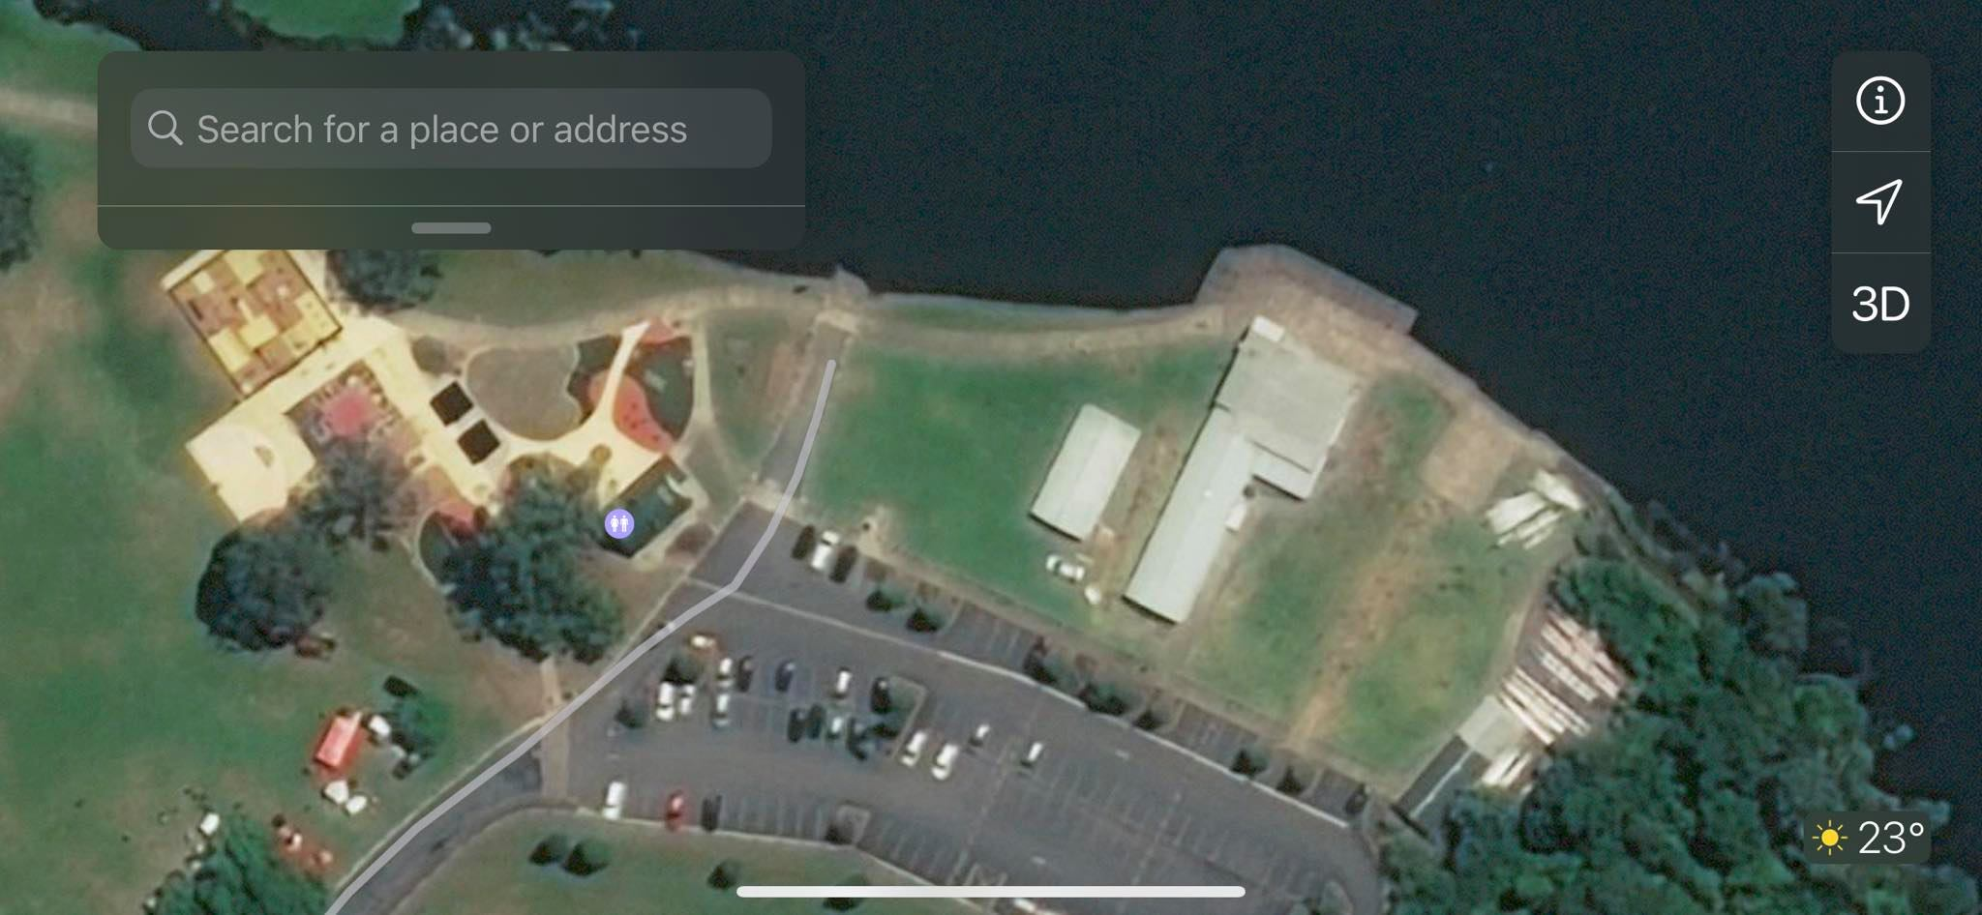
Club tents

Carparking
Stall Holders

Toilets

Club tents

Club tents

Loading Bay W1

W1 s
Loading Bay W6

Payment- please ensure payments for your club is paid into the Te Toki Voyaging Trust account before the 5th of February. No payment, no paddling. Please use the invoice generated by NKoA.

Te Toki Voyaging Trust
12-3122-0176411-00

Water- we have water station identified by the blue circle on the site map.

First Aid- St Johns will be onsite all day, their Ambulance will be situated to the right of the Yacht Club identified by the red cross on the site map.

Results- race schedule and results will be posted to the windows identified by the green circle.

Stalls- there will be a number of both food and apparel stalls at the regatta.
- Cookie Queen
- Nourish Pod
- Chur chur Hangis
- TMMKKM BBQ (Sausages, Bacon & Egg sandwich and juicies)
- Manaaki Made
- Maaori Spartan
- TTVT Apparel
Contact- for any queries prior to the regatta please email tetokiwakaama@gmail.com, for queries on the day please call or find April Irwin 021 1568820 she will be based in the Yacht Club.

